One Sweep

Game Design Document

By:

Gruodis Games

Team Members:

Augustinas Asmontas, 20248668

([augustinas.asmontas@gmail.com](mailto:augustinas.asmontas@gmail.com), 01056150626)

Oleksii Shvets, 20248684

(01021159230)

Declan Micheal Corcoran, 20248670

(01022290261)

Ewaldo Devon, 20248693

(01075835662)

Justas Andrulionis, 20248667

(01025881069)

Version: 2

2025 – 06 – 13

Table of Contents

Introduction 5

Pitch 5

Overview 5

Target audience 5

Platform 5

Inspirations 5

Core Gameplay 7

Player character 7

Movement 7

Jump 7

Dash 7

Tricks 7

Cleaning 8

Score 8

Interactables 9

Rails 9

Ramps 9

Wall jumps 9

Gravity changing pads 10

Switches 10

Environmental hazards 11

Signs and Barriers 11

Civilians 11

Game World 12

Overview 12

Levels and Stages 12

1st floor – Reception 12

2nd floor – General offices 12

3rd floor – Cafeteria 12

4th floor – IT department 12

5th floor – R&D 12

6th floor – QA 12

Art and Assets 14

References 14

Art Style 16

Color Palette 16

Environmental Design 16

Character Design 17

The Main Character 17

Civilians 17

Animation Style 17

Lighting 18

UI & UX 19

In-Game UI Elements 19

Score Counter & Multiplier 19

Clearance % 19

Dash Overlay 19

Fail Screen 19

Menu Systems 19

Main Menu 19

Continue 20

New Game 20

Level Select 20

Settings 20

Titles 20

Exit 20

Pause Menu 20

User Experience 21

Audio Design 22

Sound Effects 22

Gameplay Sound Effects 22

Environmental Sound Effects 22

Music 23

Scheduling 24

Pre-production (Month 1) 24

Production (Months 2-9) 24

Post-production (Months 10-12) 24

# Introduction

## Pitch

*Pick up your broom and make this job more interesting! Skate around, jump and do tricks to clean up all the mess that was made in one continuous motion. Each room is like a puzzle, so go and find the best line for your tricks.*

## Overview

One Sweep is a 2D side-on puzzle platformer. In this game you must clean the levels by skating over dirt using a skateboard. You can interact with elements of the level like rails to perform tricks while still cleaning surfaces.

Once the player starts moving, they cannot stop or change direction easily. Failing a trick or hitting a wall results in a failure of the level. The player restarts at the very start of the level and can try again to find the optimal line.

## Target audience

Our target players are people who like platformers that incorporate puzzle elements into the level design and people who enjoy skateboarding. Precise inputs will be required to play this game so players who enjoy challenging games are also our target audience.

## Platform

This game will be made for PC players.

## Inspirations

The are two big inspirations for this game: Bomb Rush Cyberfunk and Celeste. So why these two games?

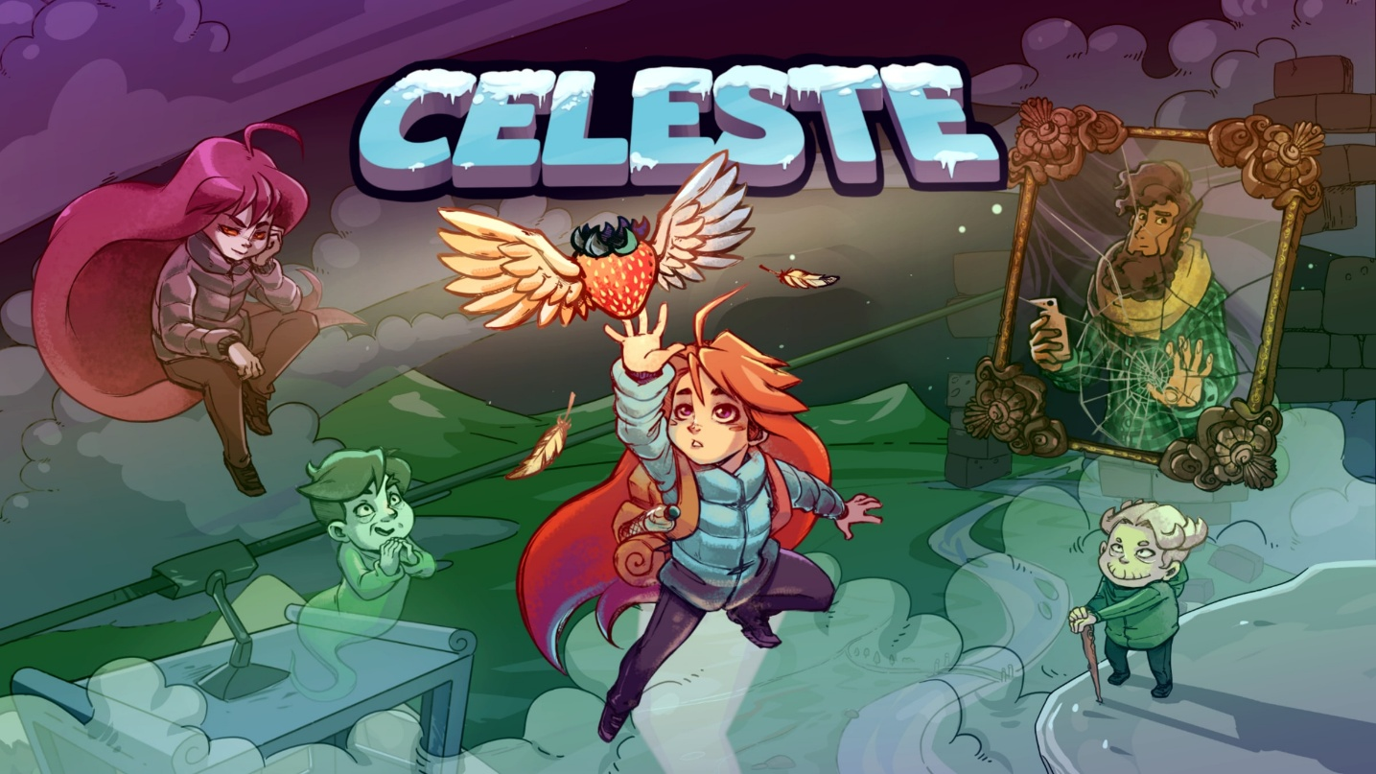

Celeste is a big inspiration for it’s simple to learn mechanics. However, these simple mechanics get used in the level design so well that it does not feel like a limitation on the player or the level design. The game introduces a dash very early on, but as the game progresses and levels get harder the simple act of dashing is still used quite a lot in all the levels. So, it is safe to say that we will draw a lot of inspiration from the level design of Celeste as well.

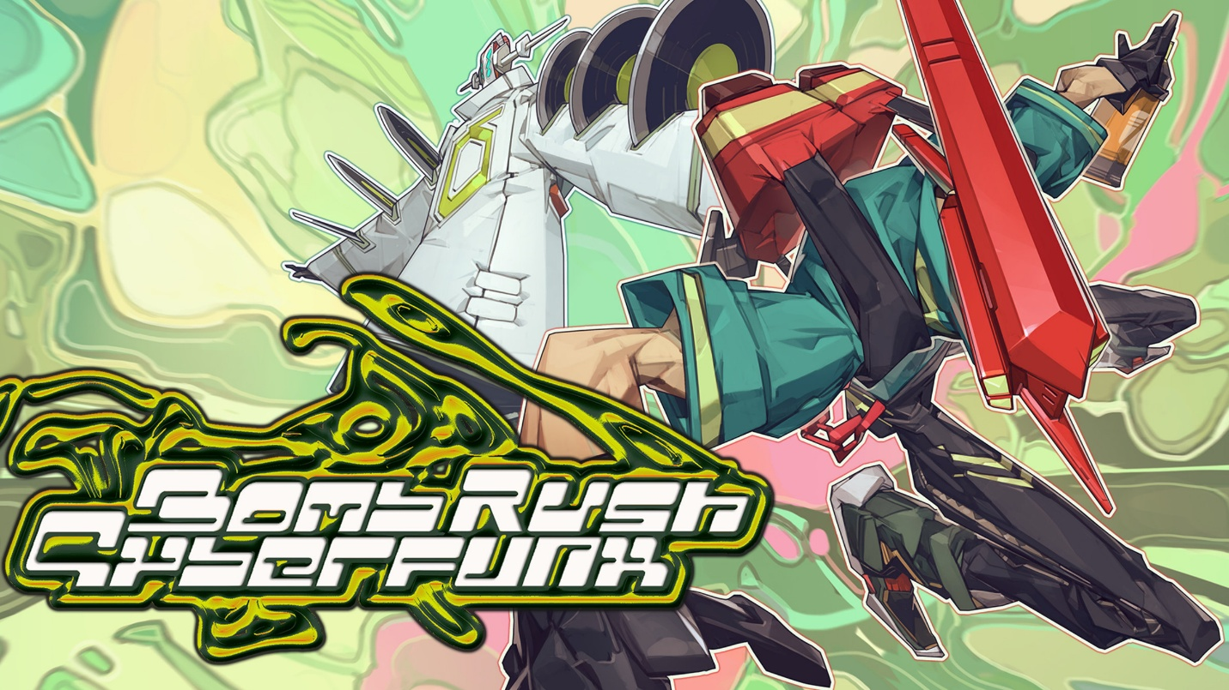

Bomb Rush Cyberfunk inspired the overall movement and feel of the game. In this game you primarily use a skateboard, roller skates or a BMX bike to traverse. The movement is simple, but if you want to get to certain areas, you must start performing tricks like grinding on rails, using ramps, and wall-ride on billboards. These pieces for traversal are also littered throughout the play area so the player can freely move however they want. This freedom movement is the core of the game, so we want our game to also feel natural and easy to move around in while keeping the continuous motion a core of our gameplay. Secondly the game inspired the ability to do manual skateboard tricks. They are not a big thing in the overall game, only getting used in certain situations or missions to progress the game. However, the player always has the option to do them however many times they want. This just gives the game some visual flare while also giving the option for players to express themselves.

# Core Gameplay

## Player character

The player will control a singular character to traverse the levels.

### Movement

The movement of the character is very simple, the player chooses a direction via input of the A or D key and starts moving in that direction.

Once the movement has started, the player cannot stop. They can perform other actions during this movement which will be went over further in the document.

The speed of movement starts of slower and as the player moves forward they gradually speed up until they reach the max speed. They can increase this build up by doing a dash or going on rails.

### Jump

The player while moving can decide to jump by pressing the SPACE key. The jump arc has a fixed height, but the cleared distance is based on the current speed of movement. Jumping does not affect the speed of the player in any way. The distance cleared does not count towards speed build up.

Jumping will let the player go over obstacles and pits to continue their movement seamlessly.

### Dash

While moving the player can choose to dash by pressing the SHIFT key, which will allow them to clear a short distance in a very quick way. This can easily be used mid jump to further extend the jump arc. As mentioned before, dashing will increase the players speed drastically.

The dash action is a one-time use ability. It is shown on the character by changing the color of the lights on them if it is active or not. This charge can be regained by doing a trick.

### Tricks

The player can perform tricks to add visual flare to their route, however, this is not the only use for doing tricks. As mentioned before performing a trick will give the player a charge of a dash.

Tricks can be performed in the air or on interactable objects. To do this, the player must only press one button. Since the player does not control the direction of movement once started this frees up the WASD keys for these tricks.

### Cleaning

This is the core mechanic of the game which progresses it. This is done automatically when going over a dirty surface. Jumping over or dashing over does not clean the surface. This adds a small amount of planning on the player’s side. They must figure out the most optimal route to clean all the dirty surfaces while still doing it in one continuous motion.

Once all of the dirt in the level is cleared, the level is completed, and the player moves on to the next stage.

### Score

Cleaning surfaces, interacting with objects add score for the player. Each cleared unit of dirt gives 100 points to the score, using an interactable that is dirty gives 500 points towards the score.

Performing a trick gives a score multiplier, this score multiplier gets applied at the end of the level.

The player will get graded after each level based on the score they accumulated. There are 4 grade levels: C, B, A and S. S is the highest possible grade and C is the lowest possible grade. By just clearing a level with no extra tricks the player gets awarded the C grade, but performing more tricks gives them a higher grade.

## Interactables

The levels will have interactables that let the player change up their movement. These interactables will not stop the player from moving to not conflict with the overall idea of the game.

### Rails

Rails will be an integral part of levels. They can be horizontal, vertical and sloped. This opens up ways to use verticality in the game.

Once on a rail the player can perform tricks, dash and jump off the rail at any moment. These rails can also be dirty so going on them will clean them.

To initiate a rail grind the player must land on them after a drop or a jump. Once on it the speed of the player get increases more than going on just the ground.

### Ramps

Another classic aspect of skateboarding games. Ramps will be used to either reach higher places that cannot be reached by a normal jump or to change the direction of the player’s movement.

To use a ramp, the player needs to only move into it. This propels them into the air and lets the player perform a trick. Upon landing on the ramp again the player’s movement direction is inverted. If while being in the air the player collides with a ramp, a rail grind is initiated and the player’s direction of movement stays unchanged.

### Wall jumps

Wall jumps are like a combination of rails and ramps. They open more opportunities for verticality usage while also providing another way to change the direction of the player.

To initiate a wall jump the player must first jump into a part of the wall that is allowed to be used for wall jumps. This will be signaled by a lit-up part of the wall. Once on that part of the wall the player will start riding up slightly, in this time pressing the jump button will propel them in the opposite direction from the wall.

Colliding with a rail works the same way as with ramps. If the player collides with another part of the wall which allows a wall jump, this lets them continue the wall jumping sequence, so wall jumps can be combined together.

If there is an even amount of wall jumps performed, the direction of the player does not change, otherwise it does change to the opposite direction of the player’s motion.

### Gravity changing pads

To continue the use of verticality in this game, a gravity changing pad is a very easy addition. This can also become a hazard if designed around that.

To initiate this pad, the player must ride over it. Once this is done, the player flips and starts riding upside down, the gravity for the player also flips. If the player jumps, they will fall in the current gravity position.

Everything else works the same as stated, but it just inverts the Y axis.

### Switches

Like most puzzle games, this game has an interactable switch which can open up new pathways or change existing ones.

To use a switch the player needs to pass through them by riding or jumping, dashing through the switch will not activate it.

Once activated it switches its state and changes whatever is assigned to it. It can be a wall opening up, changing the layout of rails or turns, activating other interactables and so on.

## Environmental hazards

To keep the game more challenging, it needs to have some sort of hazards to dodge or play around.

### Signs and Barriers

The simplest way to stop a skateboard is to put something in front of them. The in-game signs and barriers work just like that.

If the player collides with a sign or barrier, they fall down. This stops their continuous motion, and they have to restart the level. A way to dodge them is to simply jump over them or use any other interactable to evade them.

### Civilians

This is a modified version of the simple sign and barrier.

A single civilian, like in real life, does not take up as much space as a whole barrier, so they can be dashed through as a way to evade them. All the other ways of evasion also work on them.

Furthermore, civilians can be used as little jump pads. Jumping on them will propel the player upwards as if they jumped from the top of the civilian’s head again. The bounce height is the same as a normal jump and the momentum rules stay the same as in jumping.

# Game World

## Overview

The game is set in a futuristic version of our world. The whole game will be in a massive office building. Each floor houses a different department. For example, the first floor is a reception area, while the second floor would be for general offices and the fifth floor with be the R&D department. Each floor will have its own characteristics, so the player will easily know where they are in the world.

## Levels and Stages

The game is split into different levels and stages. The stage is the floor on which the player is in the building and each stage has multiple levels in them. To progress to a different floor the player must first complete all the levels on that floor.

### 1st floor – Reception

The environment of this floor has to feel welcoming as it is the reception area. This will also let the player know that the upcoming levels are not difficult since this is a tutorial stage.

For the environment it is open and simple to navigate. Signs on the floor and walls will give directions to the player on how to proceed without being to in their face.

### 2nd floor – General offices

The second floor is the first small test for the player, the guiding lines of the first floor are now gone and they must learn to navigate themselves.

Since this area is for small offices, there are more obstacles the player has to dodge, the area will be more cluttered and messier. This floor also has civilians who can be an obstacle or a helpful ramp.

### 3rd floor – Cafeteria

### 4th floor – IT department

### 5th floor – R&D

### 6th floor – QA

# Art and Assets

Since the game is set in a sci-fi world, the chosen art direction will clearly convey that. Tall buildings, sleek design and other futuristic aspects will be present. However, the free-flowing feeling of skateboarding must not be lost in this

## References

Hero are some references for the building designs

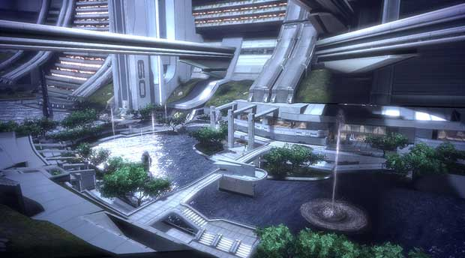

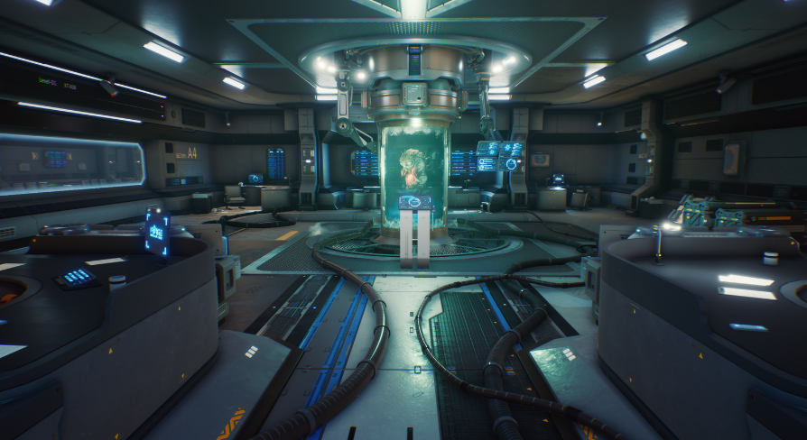

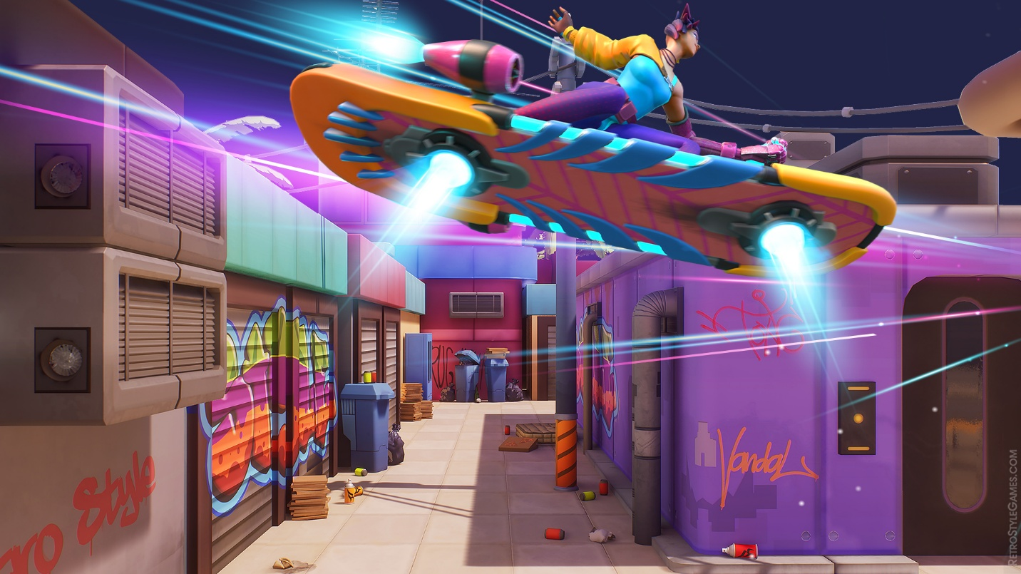

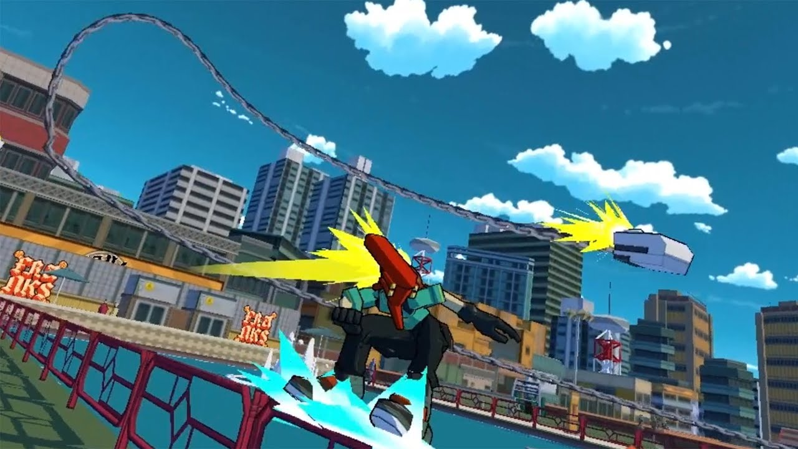

## Art Style

One Sweep will primarily use low-poly 3D assets. If the possibility arises a cel-shaded look could work really well. The most direct inspiration is Bomb Rush Cyberfunk. The game is very visually appealing and meshes well with the skateboarding aesthetic. This must further be blended with the futuristic visual style of the game.

## Color Palette

One Sweep will primarily use blue color tones. This color is usually associated with futuristic worlds. However, the use of other colors is not prohibited. Mixing blues with other colors can be used in character design, but the world should mostly focus on shades of blue.

On the first levels the colors are lighter to ease the player in, but as you progress through the game it becomes more difficult so more contrasty colors may be used to keep the player on their toes while not interfering with the gameplay.

Neon colors will be used to highlight the interactable objects. Easy to spot and recognize.

## Environmental Design

For the environment it still has the futuristic aesthetic, however, it cannot go in to being to cyberpunk, the exterior and interior must still have a sleek and slightly minimalistic look. For the overall assets they are simplified and do not have to have insane detailing on them (this is not gothic architecture). In the game no atmospheric effects will be used since everything is happening inside a building and it must remain clean. The only thing that will be present is dirt and dust on objects that need to be cleaned.

## Character Design

This section will go over the character designs of One Sweep.

### The Main Character

The main character mostly has realistic proportions, but some things can be exaggerated since he has cybernetic enhancements on his arms and chest

The costume is a general janitor’s overall, but to show off that he is a skateboarder some adjustments are made. The overall is not fully buttoned up, exposing his chest. Underneath it the character wears a tank top. This shows off the cybernetic enhancements but does not reveal everything fully. On the neck there are a pair of headphones to further go with the skateboarding aesthetic. As per shoes the character wears simple sneakers with bright colors to easily find where he is positioned. To round things out, on the arms they have chunky bracelets.

The animations of the main character must be fluid and exaggerated showing that he is having a load of fun while doing this job. Their expressiveness can be shown more trough body animations since the player will see them from further away most of the time. Silhouettes must be quite clear to easily distinguish in what state the character is (jumping, grinding on a rail, doing a trick and so on).

### Civilians

The civilians will have realistic proportions.

The costume is usual office wear like suits, shirts, dress pants, ties, skirts. They don’t need to really stand out. Just enough so they can be spotted on the screen to dodge them or use them as ramps. To achieve this, they must have a clear silhouette. There will be no expressive animations for the civilians, because they are not really needed as actual characters.

Civilians require very minimal animations, so no real guidelines are needed. A simple and clear idle animation is needed only. Where things can be a little more expressive are when they get used as a ramp or get run in to. Even then, minimal reaction will be conveyed.

## Animation Style

In general, the animations need to be smooth, to keep the flowy feel of the game. Exaggerations can be used for interactable objects as well to keep them visually distinct from the background.

The game will utilize some VFX for the grinding rails, player using dash, doing a trick and so on to add visual flare. Since the environments are futuristic, VFX will be used to exaggerate the skateboarding aspect of the game.

## Lighting

For the lighting of the levels, it will not be very realistic. Most of the time it will be flat since it is a building. The highlighted parts of objects should emit their own light on the level as well, but the main character’s shiny chest will not affect the lighting of the level at all to keep him separate and easily readable.

# UI & UX

One Sweep features a sleek, futuristic interface design that reflects the game's sci-fi aesthetic and utopian setting. The holographic-style UI elements create an immersive technological experience while maintaining the clean, minimalist approach that keeps gameplay as the primary focus.

## In-Game UI Elements

The in-game interface features sleek, holographic displays that appear to float within the game world, rendered in crisp blues, whites, and subtle neon accents.

### Score Counter & Multiplier

A score counter is positioned in the upper corner, displayed as a glowing, translucent panel that shows the player's current score accumulated through cleaning surfaces and performing tricks. The counter features subtle particle effects and smooth number transitions that activate when points are earned, providing satisfying visual feedback.

Adjacent to the score display, a dynamic multiplier indicator presents the current trick multiplier. The multiplier visualization grows and intensifies with each successful trick.

### Clearance %

The level completion percentage is displayed as a large number in the lower part of the screen and is updated real-time as the player clears a level from dirty surfaces.

### Dash Overlay

The dash ability is mainly displayed on the main character themselves, so the player would not have to rely on the UI, however a simple overlay may be applied either when a dash is gained or sustained.

### Fail Screen

When the player fails a level, a simple translucent overlay appears displaying: "Press R to Restart", "Press ESC for Pause Menu".

## Menu Systems

Consistent with the in-game UI, all menu elements adopt a clean, holographic aesthetic, with soft animations and crisp blue-neon visuals that align with the sci-fi theme. Generally, there are two menus the player can access: main menu (by accessing the game or from the pause menu), and pause menu (by pressing ‘Esc’ during gameplay)

### Main Menu

The main menu is presented as a set of options the player can interact with in the left part of the screen, presented as a futuristic application window with the title of the game on top of it. At the same time, the background is the zoom out version of the last level the player has played, if none are saved, then the first level shall be displayed instead. The animated buttons that can be interacted with will include: “Continue”, “New Game”, “Level Select”, “Settings”, “Titles”, “Exit”.

### Continue

If “Continue” is pressed, the main menu disappears and the game seamlessly transitions to the level currently loaded in the background. If none are loaded, then the button is not interactable.

### New Game

If “New Game” is pressed and there is already a save file that One Sweep can access, a window pops out on the screen warning the player that all of the progress of the current playthrough will be lost and suggesting the player to use “Level Select” instead. If the player decides to proceed, then the old save file is replaced with the new one and the player starts the game on its first level. If there were no previous save file, a new one is created and the warning does not display to the player.

### Level Select

Upon pressing “Level Select” the player is taken to the level select screen, where they can choose to replay a level they have already finished or the most recent one. The left side of the screen lists stages, their names and numbers. Clicking on them allows you to switch between different sets of levels to beat. The rest of the window is taken by a grid of levels on that stage, with a small rectangular preview of their layout, their name, number, and the highest score the player has achieved there. If one of those fields in the grid is pressed, the game launches the level.

### Settings

If “Settings” is pressed, the player is sent to the settings menu. It offers customizable controls, audio sliders, screen resolution options, and visual effect toggles (e.g., enabling/disabling certain post-processing features for performance). Settings are grouped by category with tabbed navigation or animated transitions to maintain clarity without overwhelming the player.

### Titles

Upon pressing “Level Select” the player is taken to the titles screen, where they can view all the people responsible for making the game with extra mentions of all the extra content that requires to be credited for use.

### Exit

Pressing “Exit” closes the application after updating the current save file.

### Pause Menu

The pause menu can be accessed during gameplay and looks similar to the main menu, the difference being the placement of the menu window in the middle of the screen, instead of the left part of it. The difference is also within possible options for the player to access, them being: “Continue Playing”, “Settings”, “Main Menu”. With *settings* being identical to the main menu one, *continue playing, closing* the pause menu, and *main menu* updating the save file and sending the player to the main menu.

## User Experience

The game’s flow is uninterrupted by clunky navigation or unnecessary menus—everything is streamlined to keep the player focused on movement, puzzle-solving, and expression. Menus and transitions are snappy, with minimal delay between player input and feedback, reinforcing the fast-paced and reactive nature of the gameplay. Navigation through the interface, whether with a keyboard or controller, is intuitive, with input prompts adapting in real-time to reflect the device in use. Visual feedback is clear and responsive, from glowing highlights on interactive elements to smooth transitions between screens. The UI fades into the background when not needed, ensuring the player’s attention remains on the level itself, while still providing timely information. Accessibility is also considered in the UX design, with scalable UI, toggleable visual effects, and clear iconography supporting different play styles and user needs. Ultimately, the UX reinforces the feeling of momentum, clarity, and control, helping players stay in the flow state as they puzzle their way through each continuous-motion level.

# Audio Design

The audio design of the game is very important, it must reinforce the aesthetics we are trying to hit while also making the player feel good about their gameplay and immersing the player more in to the world and in to the character they are playing.

## Sound Effects

The most crucial part in this game. Without proper sound effects the gameplay may not feel as responsive.

### Gameplay Sound Effects

The gameplay requires sound effects for each interactable like rails, ramps and so on. Each one needs to be distinct, so the player clearly knows what they are interacting with.

Aside from that the playable character must also have sound effects for riding on the skateboard, dashing, doing tricks and failing.

Using sounds that are produced during skateboarding will enhance the player immersion while also strengthening the responsiveness feeling of the game.

### Environmental Sound Effects

With these sound effects we will focus on making the world feel alive and futuristic.

The sound effects required for this can be hologram working sound, machinery sound in the background, alarms and so on. These sounds can not drown out the gameplay effects. They are just a supplement to fill in the blanks during gameplay

## Music

The music choice is very important as well. Since this is a puzzle game, high intensity music would feel wrong. However, an action packed skateboarding part of the game require some sort of appropriate music to make the player feel good. So what music is a good choice?

This game requires a very specific middle of both styles of music required by both genres of the game. The perfect genres for these are electronic music. It plays in to the futuristic and skateboarding aesthetic of the game. Specific genres are chosen for this effect: house, electro-funk, drum and bass, and other similar genres. These genres are perfect since they have a more defined beat which can be used nicely in the puzzle aspect of the game. It is not intrusive and let’s the player think easily. But when the player goes skateboarding the beat drops of these genres bring a the much needed action to it while still being not as intrusive. This let’s the player to get in to a groove of checking the level and performing in style.

Some examples from Bomb Rush Cyberfunkm which is a big inspiration for the music choice:

[JACK DA FUNK](https://www.youtube.com/watch?v=fxpkN7sFbVw&list=PLD6ujQ0tHAv2qLS5FKH6B8MjtfEg1kwsn&index=10)

[Feel The Funk](https://www.youtube.com/watch?v=BCx_mU6v-dk&list=PLD6ujQ0tHAv2qLS5FKH6B8MjtfEg1kwsn&index=15)

# Scheduling

The development of One Sweep is planned across three distinct phases spanning approximately 12 months, with each phase focusing on specific aspects of the game's creation.

## Pre-production (Month 1)

The pre-production phase establishes the foundation for the entire development process. During this month, the team will finalize the complete game design document, ensuring all mechanics, systems, and design elements are clearly defined and documented. Research will be conducted on skateboarding mechanics, puzzle-platformer level design, and reference games like Celeste and Bomb Rush Cyberfunk to inform our design decisions.

## Production (Months 2-9)

The production phase represents the bulk of development work, where the game takes shape from concept to playable experience. The first priority will be developing and implementing the core movement mechanics, including the continuous motion system, jumping, dashing, and trick performance. Once the basic player controller is stable, focus will shift to designing and prototyping individual levels, ensuring each presents unique challenges while maintaining the core gameplay loop of cleaning surfaces in one continuous motion.

Interactable elements such as rails, ramps, wall jumps, gravity pads, and switches will be implemented and tested throughout this phase. Asset creation will run parallel to gameplay development, including character animations, environments, and visual effects that enhance the skateboarding experience.

## Post-production (Months 10-12)

The post-production phase focuses on polish, optimization, and final quality assurance. Level design will be refined based on testing feedback, making sure that the game keeps balance between challenge and accessibility, while introducing new mechanics to keep it fresh. Character animations and visual effects will receive final polish to ensure smooth, responsive gameplay that feels satisfying to control.

Post-processing effects and visual enhancements will be implemented to create the final aesthetic vision for the game. Comprehensive internal playtesting will be conducted to identify and resolve any remaining bugs, balance issues, or usability problems. The final months will involve thorough debugging, performance optimization, and preparing the game for potential distribution.